**How Staples perform customer segmentation analysis to improve customer churn and retention**

Find out how STAPLES, a prominent office supply retail company makes use of Customer Segmentation Analysis, to make sense of their data. Read further, to understand the specially curated Project Insights !

**Overview**

**Staples**Inc., founded on May 1, 1986, by Thomas G. Stemberg, Leo Kahn, and Myra Hart, is a prominent American office supply retail company headquartered in Framingham, Massachusetts. The company's inception stemmed from Stemberg's frustration of not being able to find a printer ribbon during a holiday, leading to the vision of an office supply superstore. Since opening its first store in Brighton, Massachusetts, Staples has expanded significantly, now operating approximately 994 stores and 40 fulfillment centers across the United States as of 2024. Serving both U.S. and Canadian markets, Staples employs around 34,000 people and reported revenues of $8 billion for FY 2023. After being acquired by Sycamore Partners in 2017, the company was restructured into three independently managed entities, focusing on U.S. retail, Canadian retail, and B2B services. Staples is dedicated to corporate social responsibility, emphasizing inclusion and diversity, community engagement, and sustainability. The company offers over 20,000 eco-friendly products and has committed to a five-year plan to reduce its operational carbon emissions by 35%. Additionally, Staples supports its employees with substantial aid and ensures high service standards with live customer service chats typically answered within 30 seconds.

Now, let's dive into some insights (just for learning purposes!) on how Staples might analyze their data to better understand their customer segments.

**About Dataset**

Let’s Inspect our Superstore dataset. This dataset got all the deeds on sales – order IDs, order and shipping dates, shipping mode, customer names and where they're at, plus product info like category and name. And of course, we've got the numbers – sales amount, quantity, discounts, and profit.

This data enables analysis of sales performance, profitability, and customer behavior to improve supply chain management decisions. Here are some sample Rows & Columns of the Superstore Dataset 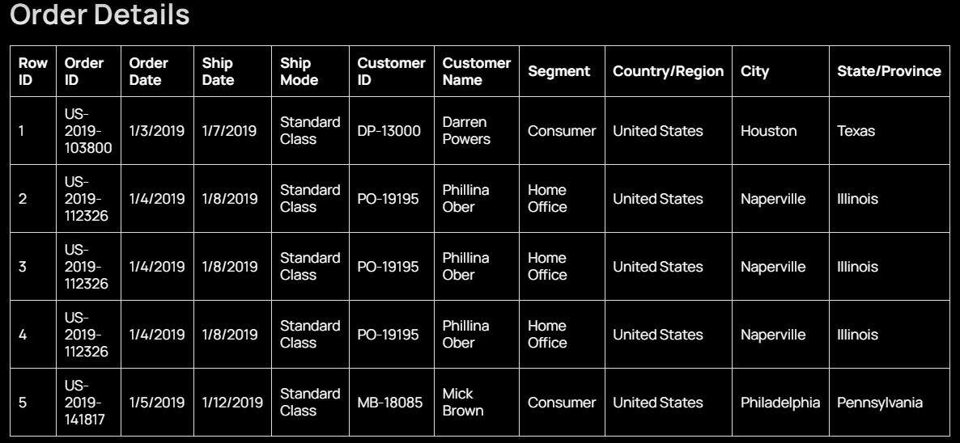

**Product Details**

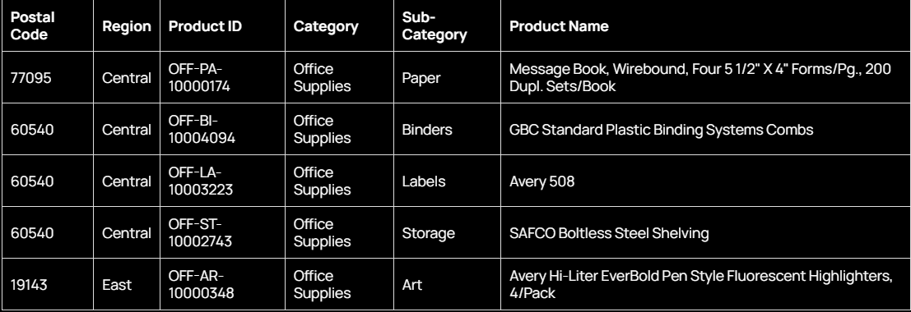

**Sales Data**

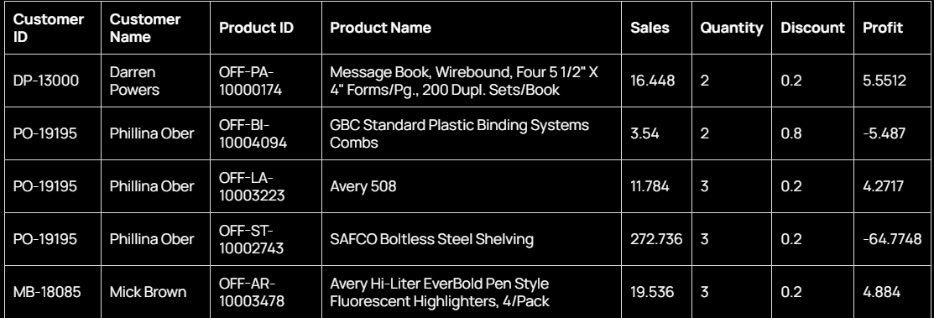

Each row in the dataset corresponds to an order made by a customer. We have the following features:

‍

**Order Shipment**

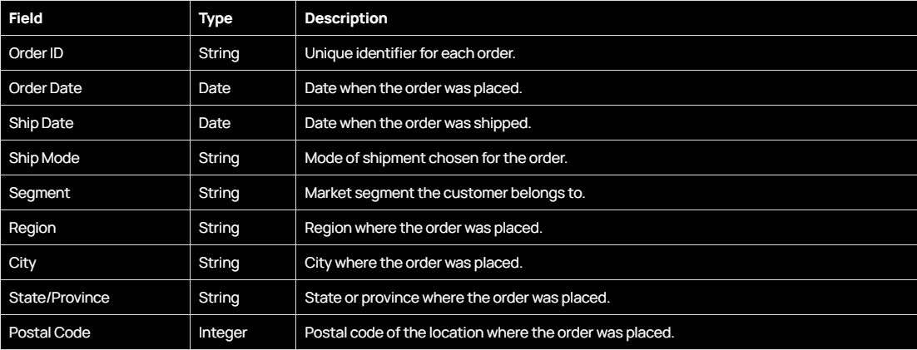

**Product**

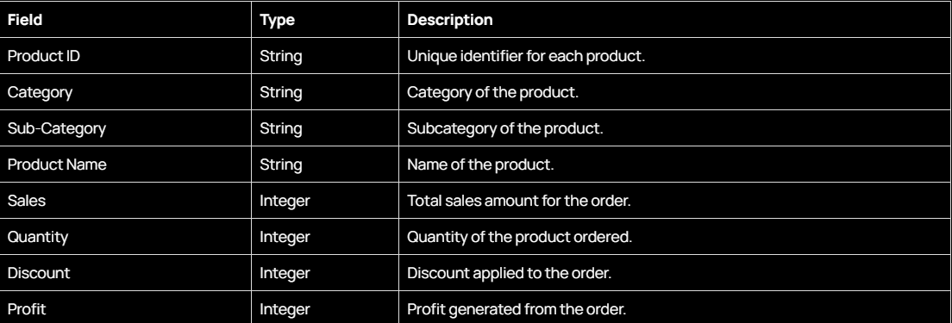

**Other Feature**

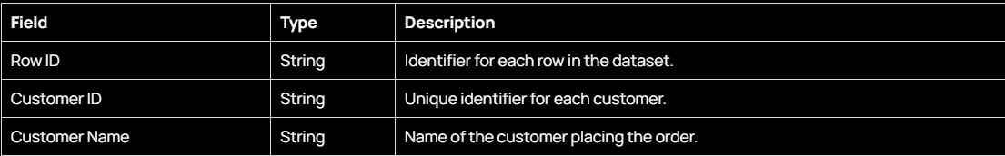

The SuperStore Dataset contains over 10194 orders and 13 of our Columns have String Data type, 4 of our Columns have Integers Data Type and 2 of the columns have Date Data Type.

**How does Staples perform customer segmentation analysis to improve their customer churn and retention?**

To begin with customer segmentation analysis, it is essential to follow these five key steps in data analysis:

Identify the users or stakeholders for the dashboard.

1. Design an Empathy Map to define users' goals and challenges or pain points.
2. Identify the most important metrics or KPIs.
3. Understand the objectives and goals.
4. Ask pertinent business questions.

In this article, we'll lay the foundation for a top-notch Customer segmentation analysis.

**Step 1: Identify the users or stakeholders for the analysis**

Define the User or stakeholder  who will use the customer segmentation analysis data story. In our case, We’ll use a Business Analyst. Recognizing their diverse needs, challenges, and priorities becomes the cornerstone for tailoring an effective data story.

**User Persona: Business Analyst**

‍

1. **Responsibilities**:

* Dive deep into company data to uncover insights driving strategic decisions.
* Collaborate with teams to understand needs and objectives.
* Use advanced analytical tools to extract valuable information.
* Translate data into actionable recommendations.
* Stay ahead in the competitive landscape by identifying trends and patterns.

‍

2. **Needs**:

* Access to comprehensive and accurate business data from various sources.
* Proficiency in analytical software for effective data manipulation.
* Strong communication skills for collaboration across departments.
* Ability to explain complex findings in understandable terms.
* Resources and tools to visualize data effectively.

‍

3. **Challenges**:

* Ensuring data quality and consistency across multiple sources.
* Handling sensitive information while adhering to data privacy regulations.
* Managing multiple projects with tight deadlines.
* Balancing competing demands and priorities.
* Delivering results quickly while maintaining accuracy.

Since, we have defined the User Persona & have mapped the needs, challenges and responsibilities. Our Next step will be to design an Empathy Map which will map the pain points of the user.

**Step 2: Design Empathy Map**

To truly connect with the experiences and expectations of a Business analyst, the creation of an empathy map is invaluable. This visual tool allows for a deeper understanding of the emotions, aspirations, and pain points of users.

By empathizing with their perspectives, we can design a data story that not only meets functional requirements but also resonates with the human elements of their roles.

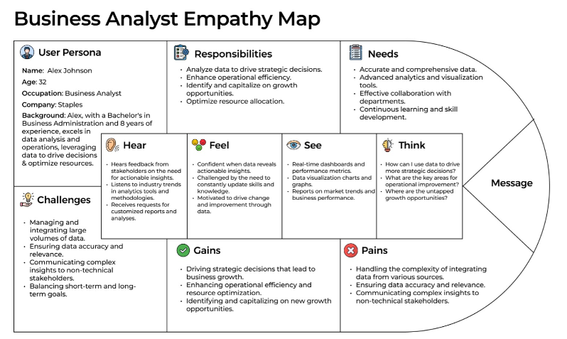

**Step 3: Identify the Key Performance Indicators (KPI’s)**

The heartbeat of any analysis lies in KPI’s and their Metrics. It's crucial to identify the KPIs that matter most to achieving the defined objectives and by focusing on the most relevant metrics, organizations can gain actionable insights into their customer segmentation analysis.

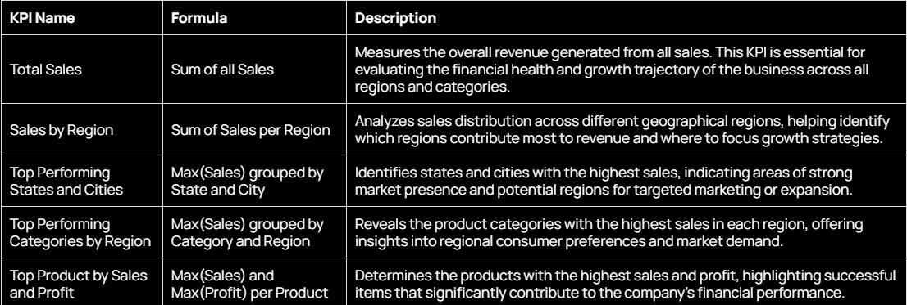

**Step 4: Understand the Goals & Objectives of User**

‍Now, based on the insights gathered from the empathy map and key performance indicators (KPIs), it's crucial to define the goals and objectives of the business analyst. This alignment ensures that the analytical efforts contribute effectively to decision-making processes. Here are the key objectives and goals:

**Objective**

The objective of the business analyst within a superstore context is to utilize data analysis techniques to drive strategic decision-making and enhance operational efficiency. By interpreting business data, the analyst aims to identify opportunities for growth, improve processes, and optimize resource allocation.

**Goals**

* **Strategic Decision-Making**: The primary goal is to provide actionable insights to support strategic decision-making processes. This includes analyzing market trends, customer behavior, and competitive intelligence to identify growth opportunities and mitigate risks.
* **Operational Efficiency**: Another goal is to improve operational efficiency by identifying bottlenecks, streamlining processes, and optimizing resource allocation. This involves analyzing workflows, identifying areas for improvement, and implementing solutions to enhance productivity.
* **Customer Satisfaction**: The analyst aims to enhance customer satisfaction by understanding customer needs and preferences through data analysis. This includes segmenting customers based on demographics, purchase history, and feedback to tailor marketing strategies and improve the overall customer experience.

By aligning with these objectives and goals, the business analyst ensures that their analytical efforts contribute to the overall success and growth of the superstore.

**Step 5 : Ask Business Questions**

Beyond KPI’s, organizations must engage in business-driven inquiry. This involves asking strategic questions that directly align with overarching business objectives.

1. **What are the average sales per customer and average profit per customer?**

* Metric: sales per customer, profit per customer
* Question: some text
  + Show me average sales per customer, average profit per customer
* Observations: Sales per customer is 1.9k and profit per customer is 361.2.



‍

1. **How do sales and profit per customer vary across different regions and categories?**

* Metric: Sales per customer, profit per customer
* Question: some text
  + Sales per customer and profit per customer by region?
  + Sales per customer and profit per customer by category?
* Observations: some text
  + West and East lead the chart for both sales and profit per customer while South and Central lags really behind.
  + Customers are spending high for Technology and Office Supplies but furniture products are performing very poorly.



‍

1. **Who are our top customers in terms of total sales and profit?**

* Metric: total sales, total profit
* Question: some text
  + Show me the customer id with total sales and profit.
  + Show me the top 100 customer id by total sales and total profit by region.
* Observation: South and Central regions seem to have customers in the lower quadrant while comparing sales vs profit.



‍

1. **Who are the customers generating negative profits?**

* Metric: total profit
* Question: some text
  + Show me the customer id with total profit having total profit less than 0.
* Observation: Central regions had the most number of customers generating negative profits which needs to be investigated further.



**Outcomes**

**‍**The analysis shows that the average sales per customer are $1,900, while the average profit per customer is $361.2. There are significant variations across regions, with the West and East leading in both sales and profit per customer, whereas the South and Central regions are lagging. In terms of product categories, Technology and Office Supplies are performing well, whereas Furniture is underperforming. Furthermore, the top customers in terms of total sales and profit are primarily from the West and East regions, while the South and Central regions have more customers with lower sales and profit. Additionally, the Central region has the highest number of customers generating negative profits, indicating a need for further investigation.

‍**Conclusion**

**‍**The disparities in sales and profit performance across regions and product categories highlight areas for potential improvement. The strong performance in the West and East regions suggests successful sales strategies that could be replicated in the South and Central regions. The high spending on Technology and Office Supplies suggests these categories are key revenue drivers, whereas the poor performance in Furniture needs attention. The issue of negative profits, particularly in the Central region, indicates underlying problems that must be addressed to enhance profitability. Strategic focus on these insights can help in improving overall business outcomes.

‍